# File permissions in Linux

## Project description

On the directory for projects there are the following issues:

* The research team has archived **.project_x.txt**, which is why it’s a hidden file. This file should not have write permissions for anyone, but the user and group should be able to read the file.
* The organization does not allow Other owner groups to have write access to any files.
* The files and directories in the projects directory belong to the researcher2 user. Only **researcher2** should be allowed to access the **drafts** directory and its contents.

Each of these situations demonstrate different operations that have to be done by cybersecurity analysts on the Linux command line.

## Check file and directory details

By using the ls command with the optional l and a, it will display the permissions of all the files inside the current directory (**l**), including the hidden files (**a**)

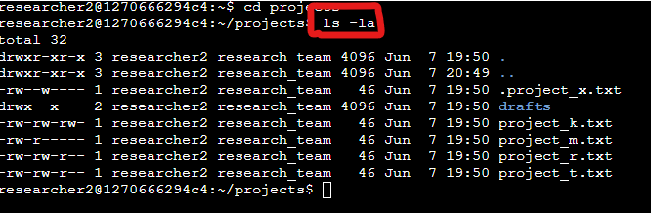

## Describe the permissions string

Using the project_k.txt file as an example.

The permissions string for the project_k.txt file describe the following:

**-rw-rw-r-**

* The **First** character in the string describes that the current selection is a file and not a directory.
* For the next 3 characters (**2nd-4th**)after, it describes that the User section group (the owner/creator of the file) has permission for read and write, but not for executing the file.
* The following 3 characters (**5th-7th**) in the string describe that the Group owner section have the read and write permissions, but do not have the permission to execute the file.
* The last 3 characters on the string (**8th-10th**) indicate that the Other owner group section has only permission to read and write, but not to execute.



## Change file permissions

Using the command chmod, which is in charge of changing the permission of a file**.project_x.txt**

We can remove from the Other owner group (**o**) the write permission (**-w**) to the file project_k.txt (**o-w**): **chmod o-w project_k.txt**

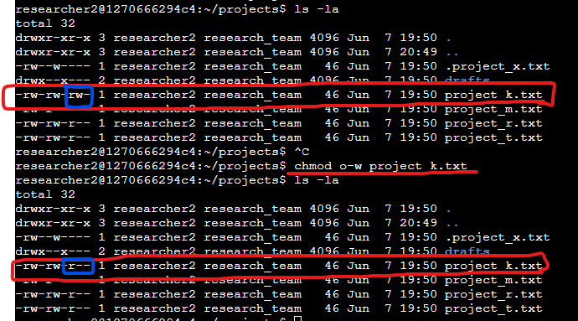

## Change file permissions on a hidden file

Using the command chmod, which is in charge of changing the permission of a file

We can remove from the Group owner group (**o**) the write permission (**-w**) and add the read permission (**+r**), and from the User owner group (**u**) remove the write permission (**-w**) to the file **.project_x.txt** (**.g-w+r,u-w**): **chmod g-w+r,u-w.project_x.txt**

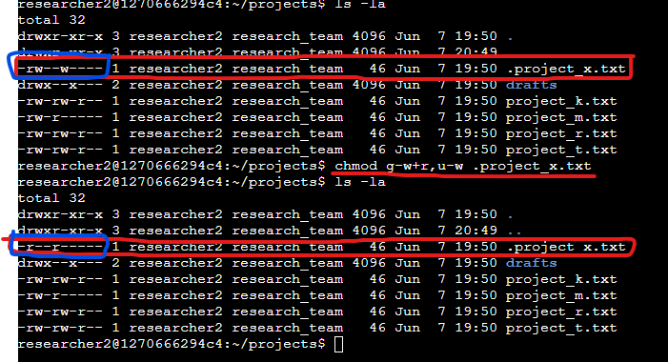

## Change directory permissions

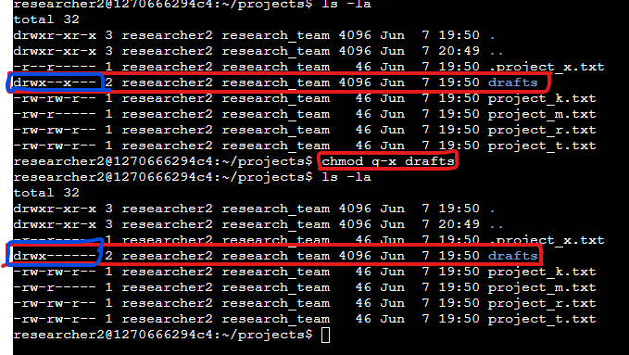

Using the command chmod, which is in charge of changing the permission of a file

We can remove from the Group owner group (**o**) the execute permission (**-x**) to the directory **drafts** (**g-x**): **chmod g-x drafts**

## Summary

I changed multiple permissions to match the level of authorization my organization wanted for files and directories in the projects directory. The first step in this was using ls -la to check the permissions for the directory. This informed my decisions in the following steps. I then used the chmod command multiple times to change the permissions on files and directories.